FINAL PROJECT – BUSINESS ARCHITECTURE

SHIVANI NANAVATI

History

An inorganic growth composing of lateral acquisition and technology innovation , the company feels the need to restrategize the growth map . The company intends to launch a transformation phase that employees and all other stakeholders find it easy to relate and use.This will help them to have an edge in the obsolete industry

Goals :

1. To study the company in context to the transformational cycle .
2. To evaluate the company’s multi-year launch transformational strategy.
3. To compare the decision the company with other companies and their models
4. To be able to recommend improvements after in-depth analysis

Deliverables :

The deliverables used is **business capabilities** map that is used as a strategic assessment for

BA principles at play

1.strategic

The company certainly has a strategic viewpoint and built on basis from recommendation of IT and business owners and setting up long term goals

2. Simple

The goals are simple and achievable as they are broken down into different year focusing on different targets

3. Reliable

There is an explanation of target measurements and its availability in the case given

4. Knowledge driven

The knowledge architecture and cross references are put to use to ensure that the intelligence derived is sourced from single knowledge driven repository

5. Sustainable

The company measures different programmes and decides upon the action based on run time,complexity. This approach is sustainable as it usually eliminates the risk of wasting resource and time

The firm under review followed a few five guiding principles for successful framework

1. Hiring a business architect :

It is evident that the business architect was hired for the transformation process . According to the open group, business architects enhance the dialogue between business managers and IT managers and set up standard interactive measures for the whole business environment. The exact purpose of this principle is justified in the use case as architects interact with leaders to create business model description and validate the technological practices .

1. Using controlled language:

A breakdown into vision,strategy intent and priorities are well established to have a standard language and goal communicated easy . The vision is to re-engineer processes and deploy new landscapes as pillars of this transformation. The strategic intent is to launch a multi year transformation programme based on their time ,length and complexity. A breakdown of bigger goal year wise. The priority is adherence to framework and constant looping in updates and improvements

1. Avoiding project failure by engaging early :

Business architects realise the need for early decision making and role recognition. Business architects take advice from managers ,business owners and IT owners . A brief plan laid out in advance will give an early alarm to unforeseen issues. There should be a balance between variation and estimates. **Denver international airport baggage handling system** had underestimated the complexity in baggage handling systems . This baggage system alone delayed the opening around sixteen months, costing almost $1.1 million everyday.

<https://www.askspoke.com/blog/it/reasons-for-it-project-failure/>

1. Gain business to IT traceability :

Architects need to decompose and analyse business structure . swimming upstream or downstream without trace is risky to the business .

<https://www.batimes.com/articles/connect-the-dots-five-tips-on-requirements-traceability.html>

**METHODOLOGIES**

One can map its steps and procedures into different frameworks for better integration .Below are the first basic ways of dividing into major elements , this is to be followed by the business architecture models

Step 01 :understand the five way framework and list down the important levers and their participants . These provide much clarity on what kind of business architecture should be referred to . Once these basics are clearly defined, it may not take time for mapping the rest of the process

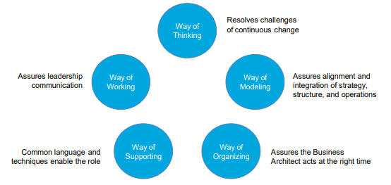

Step 02:

Understanding business architecture and their ability will make the work easy for an architect as these frameworks are defined and have a standard input ,technique and outcome. An advantage to using these types of architecture is that outcomes are pre-defined or the architect can gauge the potential of the success and implementation easily.Thus it eliminates the risk of unforeseen or uncalculated outcomes . It is also easy to integrate internally and cross use the architecture to benefit the defined framework at all the complexity level

|  |  |
| --- | --- |
| **Architecture** | **Ability** |
| **Business architecture knowledge management** | **Sharing and creative use of architecture knowledge and framework** |
| **Business architecture requirement management** | **Manage requirements from inception to completion** |
| **Business reference architecture management** | **Creation and use of reference for whole organization** |
| **Business architecture knowledge repository management** | **Includes security of all confidential information required by the organization** |
| **Business architecture delivery** | **deliver Business Architecture services during the Transformation Execution and Transformation Optimize and Learn stage.** |
| **Business architecture development** | **Analyse develop and communicate business implication** |
| **Business architecture advisory** | **Advice to internal and external customers** |

Step three:

Although the business architect framework defines the input per design, there are plenty and creative techniques to deal with the objective at different level of the transformation phase.

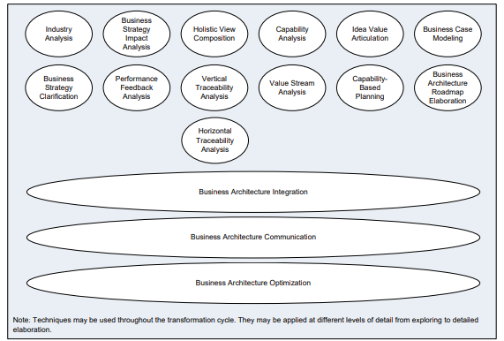

**Other frameworks**

**The federal framework and zachman are commonly used in infosys along with minor elements from other frameworks. This induces shared development of multiple processes**

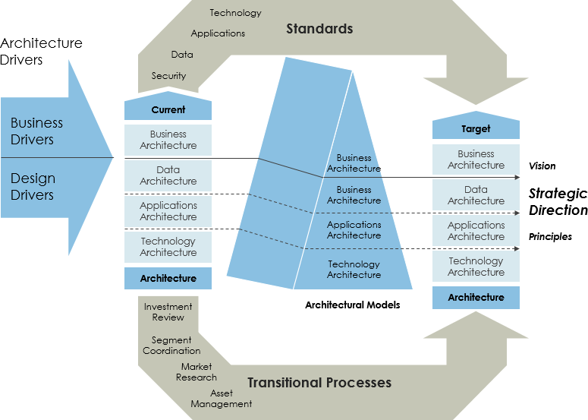

**There are other famous architectures used such as**

1. **Architecture content framework**
2. **Reference models**
3. **Enterprise continuum**

**Capablity mapping**

This mapping clearly defines the process flow in each step to avoid ambiguity. Maps are like master plans that have very clear intent and breakdown at each level during the transformation. The case under review has a multi year transformation motive,thus mapping will lead to easy transformation from one phase to another

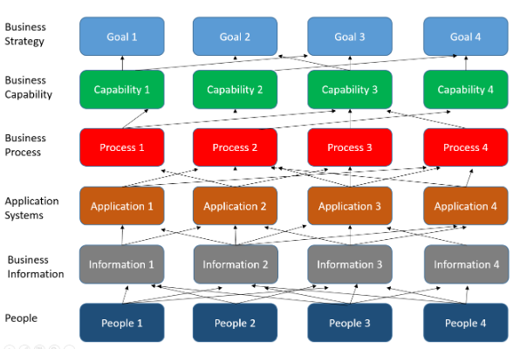

Source:<https://www.modernanalyst.com/Careers/InterviewQuestions/tabid/128/ID/5173/What-is-Business-Capability-Mapping-and-why-it-is-beneficial.aspx>

**What was actually done?**

A strategy to transform was formed by the business architecture using varied tools and techniques The leadership wanted ensure communication to end state making the strategy tangible to employees

The transformation strategy is intended to be used by different groups who could capture the business model briefly and validate the practise

There was a brief description of what the company actually strategize the requirements for process, structure,technology and people

There is a multiyear transformation launch business, IT and functions are highly taken into consideration

There is a definite metric and measure of progress and that too at an aggregated level( business capabilities planning and holistic integrated view)

A business capability map and maturity level of every competency was recorded

**Business architecture development** was used in this case as the key theme is to loop back , this shows that there is a **business architecture knowledge** management . This capability requires a well developed business architecture **requirement** management . The system as mentioned open to continuous adjustment all over the organization may use a business **reference** architecture management . Accepting inputs from IT owners,business owners signify a welcome of business architecture **advisory.**

All architecture used are **interdependen**t on each other with common techniques applied .

Techniques used in this case as mentioned are each capablity’s target **maturity level**

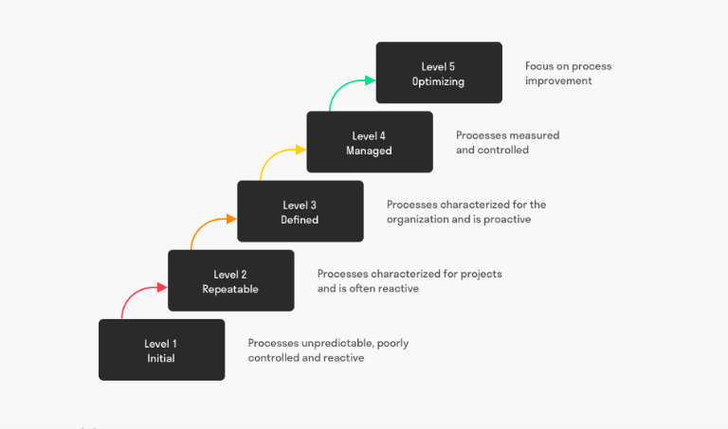

source:<https://www.toolshero.com/information-technology/capability-maturity-model-integration/>

Each capability is put into grids depending upon their maturity level . level 1 being the initial phase to level 5 being the most optimal. This rating helps architects to understand where the resources should be diverted and deployed most in each phase. In the give case,The IT team and their skill capability can be put to **level 4** as they have been operating in this field for a couple of years and the architects have already established standards of measuring procedure and outcomes. Thus as the transformation cycle peddles forward, the capabilities shall keep getting rated and worked upon

The tools used in the case are the following

1. Industry analysis
2. Holistic view compilation
3. Capability analysis
4. Business case modelling
5. Performance feedback analysis
6. Value stream analysis
7. Capability based planning
8. Business architecture integration
9. Business architecture communication

**What was missing?**

The framework integration and detailed combination was poorly addressed in the case . There should be **comparison** of different business architecture and not only IT architecture across the framework including the previous records and updates. There was no mention during the transformation about the use or appreciation of the **existing resources** unlike infosys that has two fold motives

1. Source framework from previous research
2. Populate the exhaustive list of elements into different abstractions like( what,how,where,when,who ,why) of the zachman framework and compare them to derive exclusive list

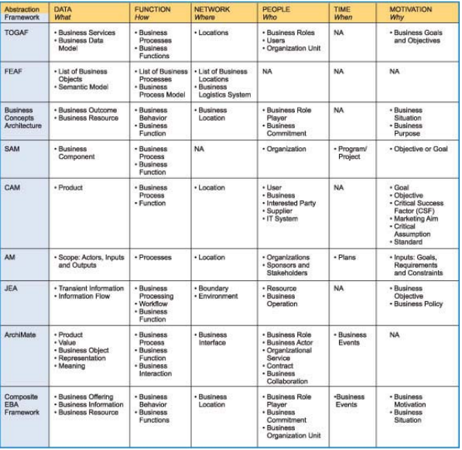

Source:<https://www.infosys.com/consulting/architecture-services/white-papers/Documents/enterprise-business-architecture.pdf> varied combination of architecture

2. What data is to be extracted?

Inspired by Infosys the company under review should have Metamodels developed due to heavy data churning given the nature of the operations. For example **structural concepts** that includes stakeholders and actors ,**behavioural concepts** like business behaviour and organizational behaviour and **informational concepts** comprising representation and meaning , product,content value etc (mcdavid archimate business meta model)

3. The strategy to be more traceable

Tools and techniques such as **horizontal traceability** and **vertical traceability** have not been applied yet. Business impact analysis seems to be overlooked. There is no mention of collateral consequences of this transformation.

In the greenfield service provider case there have been clear traceable milestones such as successful loyalty programme, BI capability for behaviour and dynamic marketing and knowing your customer.

4. Derivation

The strategic key principles that led to successful implication in the green field project was that the strategy was based on stakeholder interviews. The case under review did take help from the IT and business owners but there was no mention of **employees** and customers.

**Recommendations for the next step**

What went well ?

The company condensed ADM and their tools and techniques effectively. There was a great emphasis on including the business perspective rather than simply including the IT recommendations.The awareness and model looping of every recommendation and updates with standard communication into the system helped the company stay afloat and saved time and resources .The holistic approach gave a better clarity to roles and responsibilities which turned out to be key contributors for communication and IT alignment and governance transformation strategy. This directs the company towards successful programme achievement

1. Implementing deeper mapping within varied architecture
2. Modify to include extra mapping of architecture
3. Creating organisational mapping with maturity level of capability maps
4. The company along with ADM can use the zachman model as the zachman framework suits the nature of the company and its given operating discipline . This model is dedicated to IT companies exclusively .It is easy to understand and it helps to define tools and methodologies and they can be flexible in fitting.

The grids include what?(data),how(function),where(location),who(people),when(time),why(motivation)

The vertical grids include scope planner, enterprise model, system model designer,Technology model implementer detailed representation , functioning system

This method provides flexibility for varied combinations through different phases of transformation .

**Recommendations on how to transform/covert from ADM to zachman according to the open group?**

1 : develop the vision

2: develop business architecture

3. The information system architecture

1. Data architecture
2. Application architecture

4. Technology architecture - This includes an entire building block of Technology model implementer detailed representation.

5. Selecting the building block and then conducting the gap analysis

<https://www.opengroup.org/architecture/0210can/togaf8/doc-review/togaf8cr/c/p4/zf/zf_mapping.htm#Mapping>

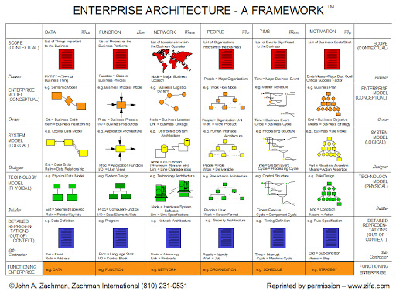

Recommendations for the next phase : As the basics goals and plans have been laid out. I recommend that there should be more focus on internal and strong cross reference and mapping between various architectures that ought to be revised at every stage .